Necessary Formulas:

- Entropy, E = – ∑ p_{i} log₂ p_{i |}; i = 1 to k, where k = number of classes.
- Average Entropy, E_{New} = ∑ w_{i} E_{i |}; i = 1 to n, where n = number of unique values for an attribute.
- Information Gain, Ig = E_{Start} - E_{New}

Iteration 1 (For Selecting the Root Node)

We have 3 classes. So, The Value of Initial Entropy, E_{Start} will be:

E_{Start} = – p₁ log₂ p₁ – p₂ log₂ p₂ – p₃ log₂ p₃

There are 4 instances with classification 1, 5 instances with classification 2 and 15 instances with classification 3. So, p₁ = (4/24), p₂ = (5/24) and p₃ = (15/24).

E_{Start} = – (4/24) log₂ (4/24) – (5/24) log₂ (5/24) – (15/24) log₂ (15/24)
= 0.4308 + 0.4715 + 0.4238
= 1.3261 bits

Now, we need to calculate E_{New} for each of the attributes.

Calculating Entropy for different Values of Age
For Age = 1,  E₁ = − (2/8) log₂ (2/8) − (2/8) log₂ (2/8) − (4/8) log₂ (4/8)  = 0.5 + 0.5 +0.5  = 1.5 |  | For Age = 2,  E₂ = − (1/8) log₂ (1/8) − (2/8) log₂ (2/8) − (5/8) log₂ (5/8)  = 0.375 + 0.5 +0.4238  = 1.2988 |  | For Age = 3,  E₃ = − (1/8) log₂ (1/8) − (1/8) log₂ (1/8) − (6/8) log₂ (6/8)  = 0.375 + 0.375 + 0.3113  = 1.0613
E_{New} (Age) = (8/24) E₁ + (8/24) E₂ + (8/24) E₃ = 1.2867 bits
Information Gain, Ig (Age) = E_{Start} - E_{New} (Age) = 1.3261 – 1.2867 = 0.0394 bits

Calculating Entropy for different Values of SpecRx
For SpecRx = 1,  E₁ = − (3/12) log₂ (3/12) − (2/12) log₂ (2/12) − (7/12) log₂ (7/12)  = 0.5 + 0.4308 + 0.4536  = 1.3844 |  | For SpecRx = 2,  E₂ = − (1/12) log₂ (1/12) − (3/12) log₂ (3/12) − (8/12) log₂ (8/12)  = 0.2988 + 0.5 + 0.3900  = 1.1887
E_{New} (SpecRx) = (12/24) E₁ + (12/24) E₂ = 1.2866 bits
Information Gain, Ig (SpecRx) = E_{Start} - E_{New} (SpecRx) = 0.0395 bits

Calculating Entropy for different Values of Astig
For Astig = 1,  E₁ = − (0/12) log₂ (0/12) − (5/12) log₂ (5/12) − (7/12) log₂ (7/12)  = 0 + 0.5263 + 0.4536  = 0.9799 |  | For Astig = 2,  E₂ = − (4/12) log₂ (4/12) − (0/12) log₂ (0/12) − (8/12) log₂ (8/12)  = 0.5283 + 0 + 0.3900  = 0.9183
E_{New} (Astig) = (12/24) E₁ + (12/24) E₂ = 0.9491 bits
Information Gain, Ig (Astig) = E_{Start} - E_{New} (Astig) = 0.377 bits

Calculating Entropy for different Values of Tears
For Tears = 1,  E₁ = − (0/12) log₂ (0/12) − (0/12) log₂ (0/12) − (12/12) log₂ (12/12)  = 0 + 0 + 0  = 0 |  | For Tears = 2,  E₂ = − (4/12) log₂ (4/12) − (5/12) log₂ (5/12) − (3/12) log₂ (3/12)  = 0.5283 + 0.5263 + 0.5  = 1.5546
E_{New} (Tears) = (12/24) E₁ + (12/24) E₂ = 0.7773 bits
Information Gain, Ig (Tears) = E_{Start} - E_{New} (Tears) = 0.5488 bits

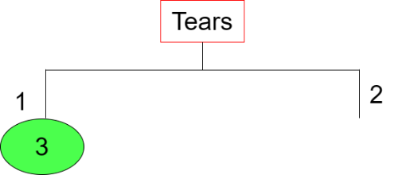

Iteration 2 (For Branch Tears = 2)

There are 4 instances with classification 1, 5 instances with classification 2 and 3 instances with classification 3. So, p₁ = (4/12), p₂ = (5/12) and p₃ = (3/12).

E_{Start} = – (4/12) log₂ (4/12) – (5/12) log₂ (5/12) – (3/12) log₂ (3/12)
= 0.5283 + 0.5263 + 0.5
= 1.5546 bits

Now, we need to calculate E_{New} for each of the attributes.

Calculating Entropy for different Values of Age
For Age = 1,  E₁ = − (2/4) log₂ (2/4) − (2/4) log₂ (2/4) − (0/4) log₂ (0/4)  = 0.5 + 0.5 + 0  = 1.0 |  | For Age = 2,  E₂ = − (1/4) log₂ (1/4) − (2/4) log₂ (2/4) − (1/4) log₂ (1/4)  = 0.5 + 0.5 + 0.5  = 1.5 |  | For Age = 3,  E₃ = − (1/4) log₂ (1/4) − (1/4) log₂ (1/4) − (2/4) log₂ (2/4)  = 0.5 + 0.5 +0.5  = 1.5
E_{New} (Age) = (4/12) E₁ + (4/12) E₂ + (4/12) E₃ = 1.3333 bits
Information Gain, Ig (Age) = E_{Start} - E_{New} (Age) = 1.5546 – 1.3333 = 0.2213 bits

Calculating Entropy for different Values of SpecRx
For SpecRx = 1,  E₁ = − (3/6) log₂ (3/6) − (2/6) log₂ (2/6) − (1/6) log₂ (1/6)  = 0.5 + 0.5283 + 0.4308  = 1.4591 |  | For SpecRx = 2,  E₂ = − (1/6) log₂ (1/6) − (3/6) log₂ (3/6) − (2/6) log₂ (2/6)  = 0.4308 + 0.5 + 0.5283  = 1.4591
E_{New} (SpecRx) = (6/12) E₁ + (6/12) E₂ = 1.4591 bits
Information Gain, Ig (SpecRx) = E_{Start} - E_{New} (SpecRx) = 0.096 bits

Calculating Entropy for different Values of Astig
For Astig = 1,  E₁ = − (0/6) log₂ (0/6) − (5/6) log₂ (5/6) − (1/6) log₂ (1/6)  = 0 + 0.2192 + 0.4308  = 0.6500 |  | For Astig = 2,  E₂ = − (4/6) log₂ (4/6) − (0/6) log₂ (0/6) − (2/6) log₂ (2/6)  = 0.3900 + 0 + 0.5283  = 0.9183
E_{New} (Astig) = (6/12) E₁ + (6/12) E₂ = 0.7842 bits
Information Gain, Ig (Astig) = E_{Start} - E_{New} (Astig) = 0.7704 bits

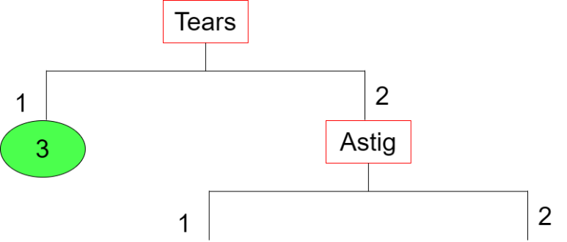

Iteration 3 (For Branch Astig = 1)

There are 5 instances with classification 2 and 1 instance with classification 3. So, p₁ = (5/6) and p₂ = (1/6).

E_{Start} = – (5/6) log₂ (5/6) – (1/6) log₂ (1/6)
= 0.2192 + 0.4308
= 0.65 bits

Now, we need to calculate E_{New} for each of the attributes.

Calculating Entropy for different Values of Age
For Age = 1,  E₁ = − (0/2) log₂ (0/2) − (2/2) log₂ (2/2) − (0/2) log₂ (0/2)  = 0 + 0 + 0  = 0 |  | For Age = 2,  E₂ = − (0/2) log₂ (0/2) − (2/2) log₂ (2/2) − (0/2) log₂ (0/2)  = 0 + 0 + 0  = 0 |  | For Age = 3,  E₃ = − (0/2) log₂ (0/2) − (1/2) log₂ (1/2) − (1/2) log₂ (1/2)  = 0 + 0.5 + 0.5  = 1
E_{New} (Age) = (2/6) E₁ + (2/6) E₂ + (2/6) E₃ = 0.3333 bits
Information Gain, Ig (Age) = E_{Start} - E_{New} (Age) = 0.6500 – 0.3333 = 0.3167 bits

Calculating Entropy for different Values of SpecRx
For SpecRx = 1,  E₁ = − (0/3) log₂ (0/3) − (2/3) log₂ (2/3) − (1/3) log₂ (1/3)  = 0 + 0.3900 + 0.5283  = 0.9183 |  | For SpecRx = 2,  E₂ = − (0/3) log₂ (0/3) − (3/3) log₂ (3/3) − (0/3) log₂ (0/3)  = 0 + 0 + 0  = 0
E_{New} (SpecRx) = (3/6) E₁ + (3/6) E₂ = 0.4592 bits
Information Gain, Ig (SpecRx) = E_{Start} - E_{New} (SpecRx) = 0.1908 bits

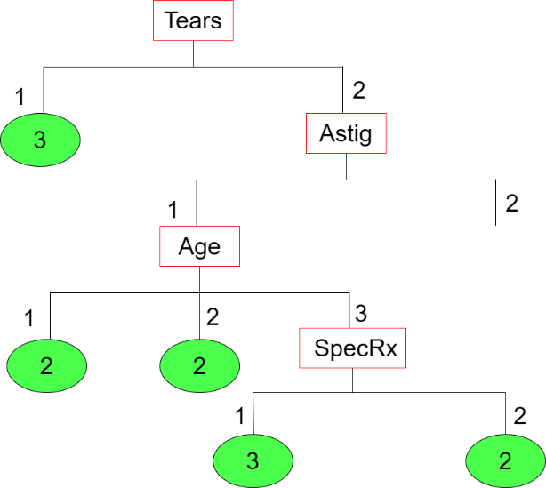

Iteration 4 (For Branch Astig = 2)

There are 4 instances with classification 1 and 2 instance with classification 3. So, p₁ = (4/6) and p₂ = (2/6).

E_{Start} = – (4/6) log₂ (4/6) – (2/6) log₂ (2/6)
= 0.3900 + 0.5283
= 0.9183 bits

Now, we need to calculate E_{New} for each of the attributes.

Calculating Entropy for different Values of Age
For Age = 1,  E₁ = − (2/2) log₂ (2/2) − (0/2) log₂ (0/2) − (0/2) log₂ (0/2)  = 0 + 0 + 0  = 0 |  | For Age = 2,  E₂ = − (1/2) log₂ (1/2) − (0/2) log₂ (0/2) − (1/2) log₂ (1/2)  = 0.5 + 0 + 0.5  = 1 |  | For Age = 3,  E₃ = − (1/2) log₂ (1/2) − (0/2) log₂ (0/2) − (1/2) log₂ (1/2)  = 0.5 + 0 + 0.5  = 1
E_{New} (Age) = (2/6) E₁ + (2/6) E₂ + (2/6) E₃ = 0.6667 bits
Information Gain, Ig (Age) = E_{Start} - E_{New} (Age) = 0.9183 – 0.6667 = 0.2516 bits

Calculating Entropy for different Values of SpecRx
For SpecRx = 1,  E₁ = − (3/3) log₂ (3/3) − (0/3) log₂ (0/3) − (0/3) log₂ (0/3)  = 0 + 0 + 0  = 0 |  | For SpecRx = 2,  E₂ = − (1/3) log₂ (1/3) − (0/3) log₂ (0/3) − (2/3) log₂ (2/3)  = 0.5283 + 0 + 0.3900  = 0.9183
E_{New} (SpecRx) = (3/6) E₁ + (3/6) E₂ = 0.4592 bits
Information Gain, Ig (SpecRx) = E_{Start} - E_{New} (SpecRx) = 0.4591 bits

